Mountain Top Marriages Overnight Retreat

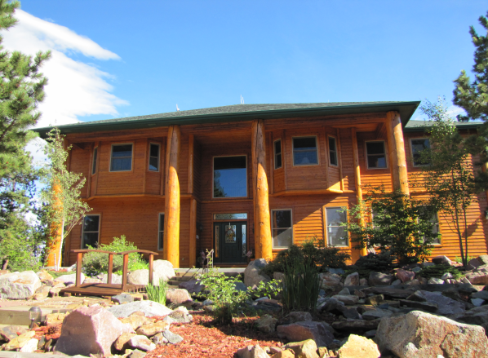

Overnight Marriage Retreat
October 19, 20, 2018
Check in at lodge between 3-4 pm
Dinner served at 5:00pm - Meeting at 6:00pm
"
Marriage Concepts Teachers
Roger & Laureen Traver

Location
“El Tesoro Retreat Center”
4 Mile up Trout Creek Rd- Rt. on Blossom Rd., Woodland Park, CO 80814
A beautiful retreat center with a spectacular view of Pikes Peak.

Cost Includes
$150.00 per couple, including $50 deposit due when reservation is made
Reservation deadline: Oct. 1, 2018
Three meals, teachings & lodge room
Check in after 3pm on Fri. Dinner at 5pm

Teaching times: Friday night 6:00pm-9:00pm
Sat. 9:00am–Noon, 1:00-3:30pm
Note:
Sleeping rooms are available on first come, first serve basis. When all the rooms are full, you can still attend the teachings and enjoy the meals at the registration cost of $50.00 per couple which will cover the meals and reserve a seat for the teachings. However, you will need to make your own overnight hotel reservations. A Suggestion: The Country Lodge Motel (719-687-6277) in Woodland Park is about 4½ miles from “El Tesoro Retreat Center" meeting place.

Contact: Roger @ 913-780-3423 or June @ 440-4175 to make reservations. Make checks payable to Mountain Top Marriages and mail to Traver/Mountain Top Marriages, 4419 Centennial Blvd., #226 Colorado Springs, CO 80907. Deposits are non refundable. If you are unable to attend, we ask that you find another couple to enjoy the retreat.

